
Focus Brain Therapy
June 17, 2026
Concept/Mockup – Internal Review

Existing Client website: https://focusbraintherapy.com/
Concept/Mockup: https://focusbrain-kappa.vercel.app/
HOME
There is currently no way for users to navigate back to the home page from other pages on the website including the Footer.

Reword this as follows on 2 lines with line 2 being a smaller font size and centered under line 1.
Our team is here for you.
Whether you’re recovering from an injury or proactively supporting your brain health.
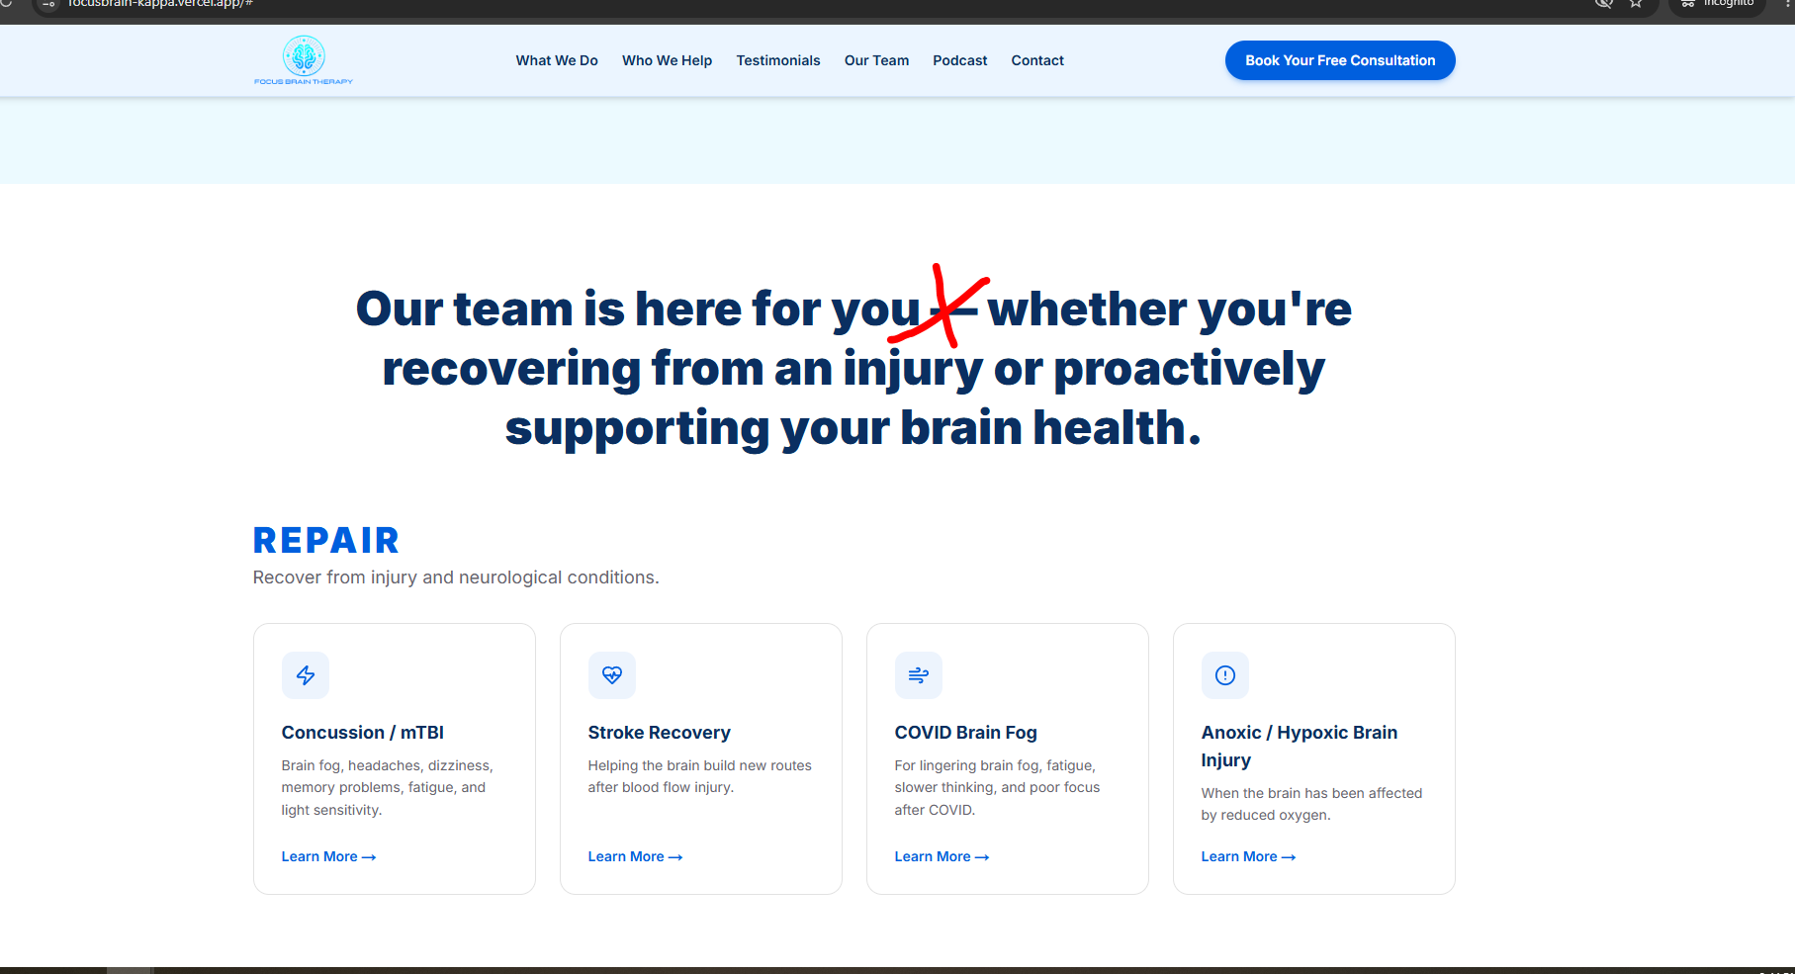

PATIENT STORIES
Change sub-title to make it on two lines and center under the title, add the trademark symbol at the end:
Hear from patients who reclaimed their lives through the
Cognitive Circuit Training Program®
- Replace all the testimonials and replace with the ones on Google.
- You do a search on Google for Neurocity Junction and you see the reviews as shown below
- Remove any names or reference that says Neurocity Junction.
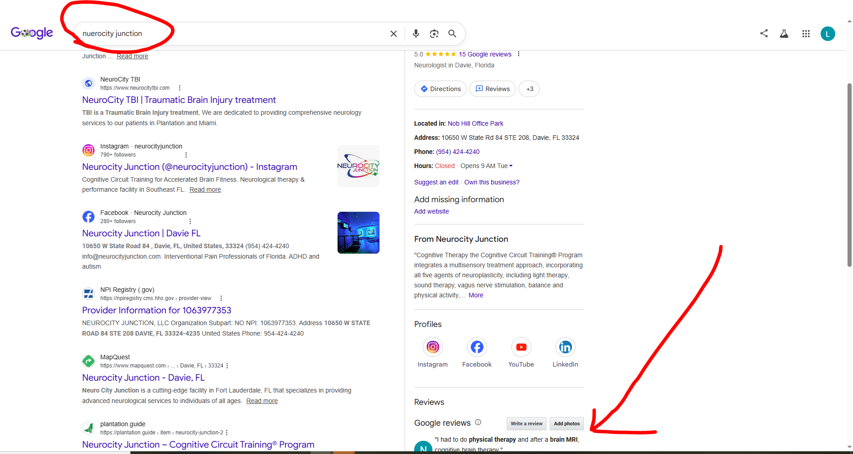

Place the 5 stars on the website with arrows to see more if there are too many on the website. Not sure how many rows you need to have so it looks nice.
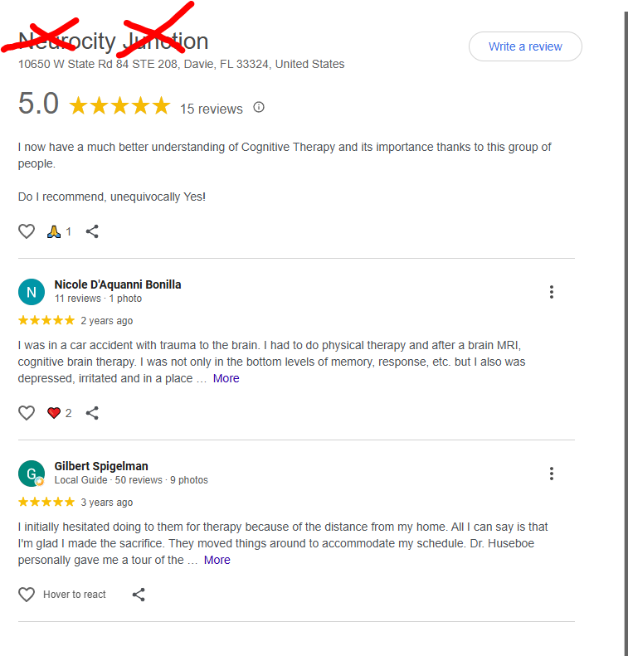
There was a button below but I don’t see it now. If you can add it back change the text to the following. Not sure if it will be too much if you add under the arrows?
Change text to: Build a better brain to build a better life.
Don’t make it clickable.

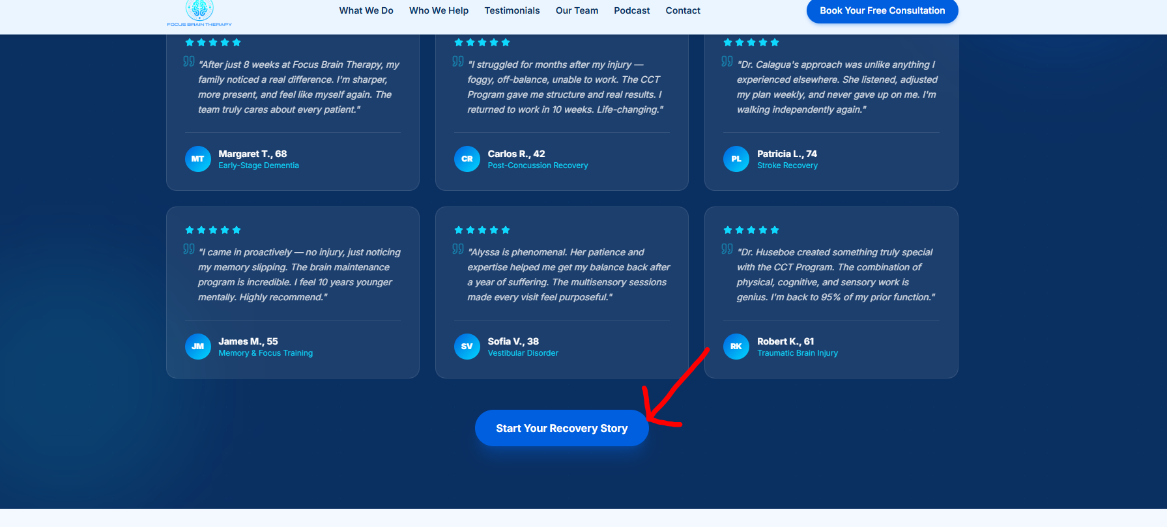
INSURANCE ACCEPTED
Change text and center it under title to:
Medicare, PPO Plans, State Workers’ Compensation, Federal Workers’ Compensation
Financing Available
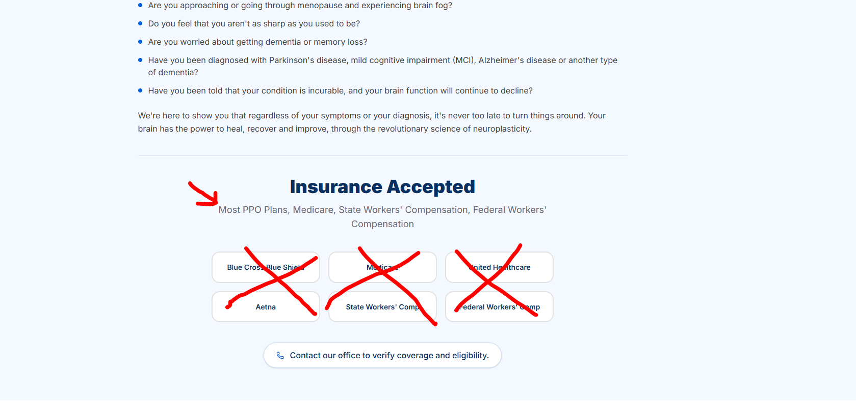
06-17-26 Internal Feedback/comments
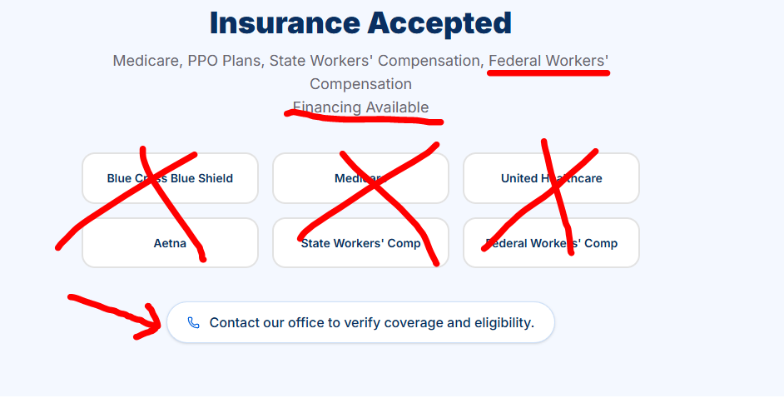
- If Federal Workers’ Compensation cannot go on first line, put it on the second one by itself.
- Make Financing Available in italics
- Missed: Remove all the buttons
- Make contact button clickable
Example:
Medicare, PPO Plans, State Workers’ Compensation,
Federal Workers’ Compensation
Financing Available
or
Medicare, PPO Plans, State Workers’ Compensation, Federal Workers’ Compensation
Financing Available

FOOTER
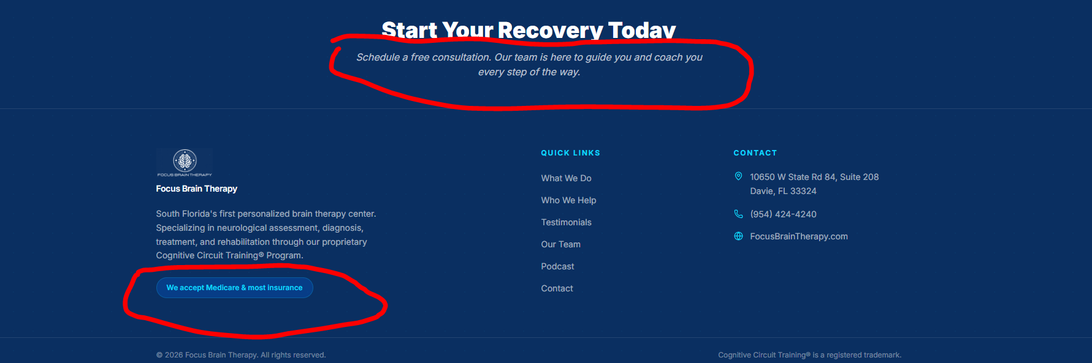
New comments/feedback
Change and center text under title to the following;
Make line one a little smaller than the title in italics.
Example:
Start Your Recovery Today
Schedule a free consultation.
Our team is here to guide you and coach you every step of the way.

Change button text to if it all fits.
Medicare, PPO Plans, State Workers’ Compensation, Federal Workers’ Compensation
Financing Available
CONTACT US
Change and center text under title to the following;
Make line one a little smaller than the title in italics.
Start Your Recovery Today
Schedule a free consultation.
Our team is here to guide you and coach you every step of the way.
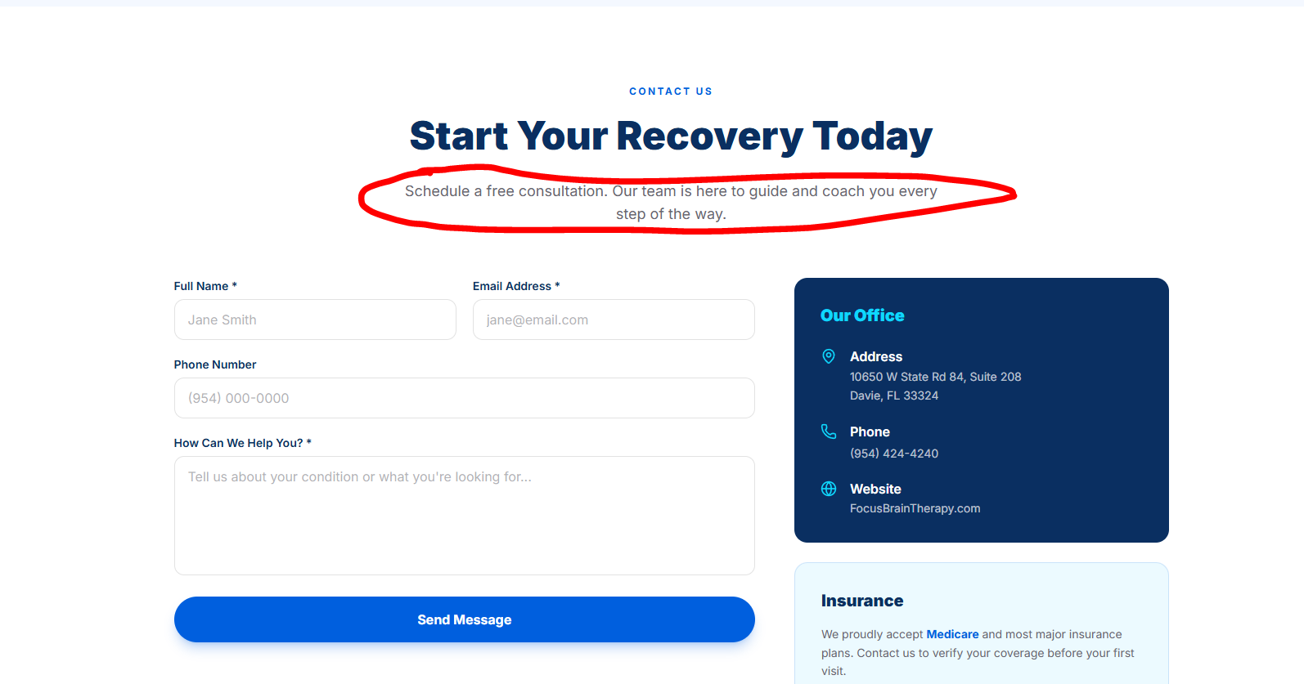
NEW CLIENT FEEDBACK:
HOME
- Add this across the top of the website in between the logo and the menu/toolbar:
Build a better brain… Build a better life
- Please make it large. They want to catch people’s attention. Client said: It’s what people come to us for.
- Remove the two bubbles build a better brain build a better life.

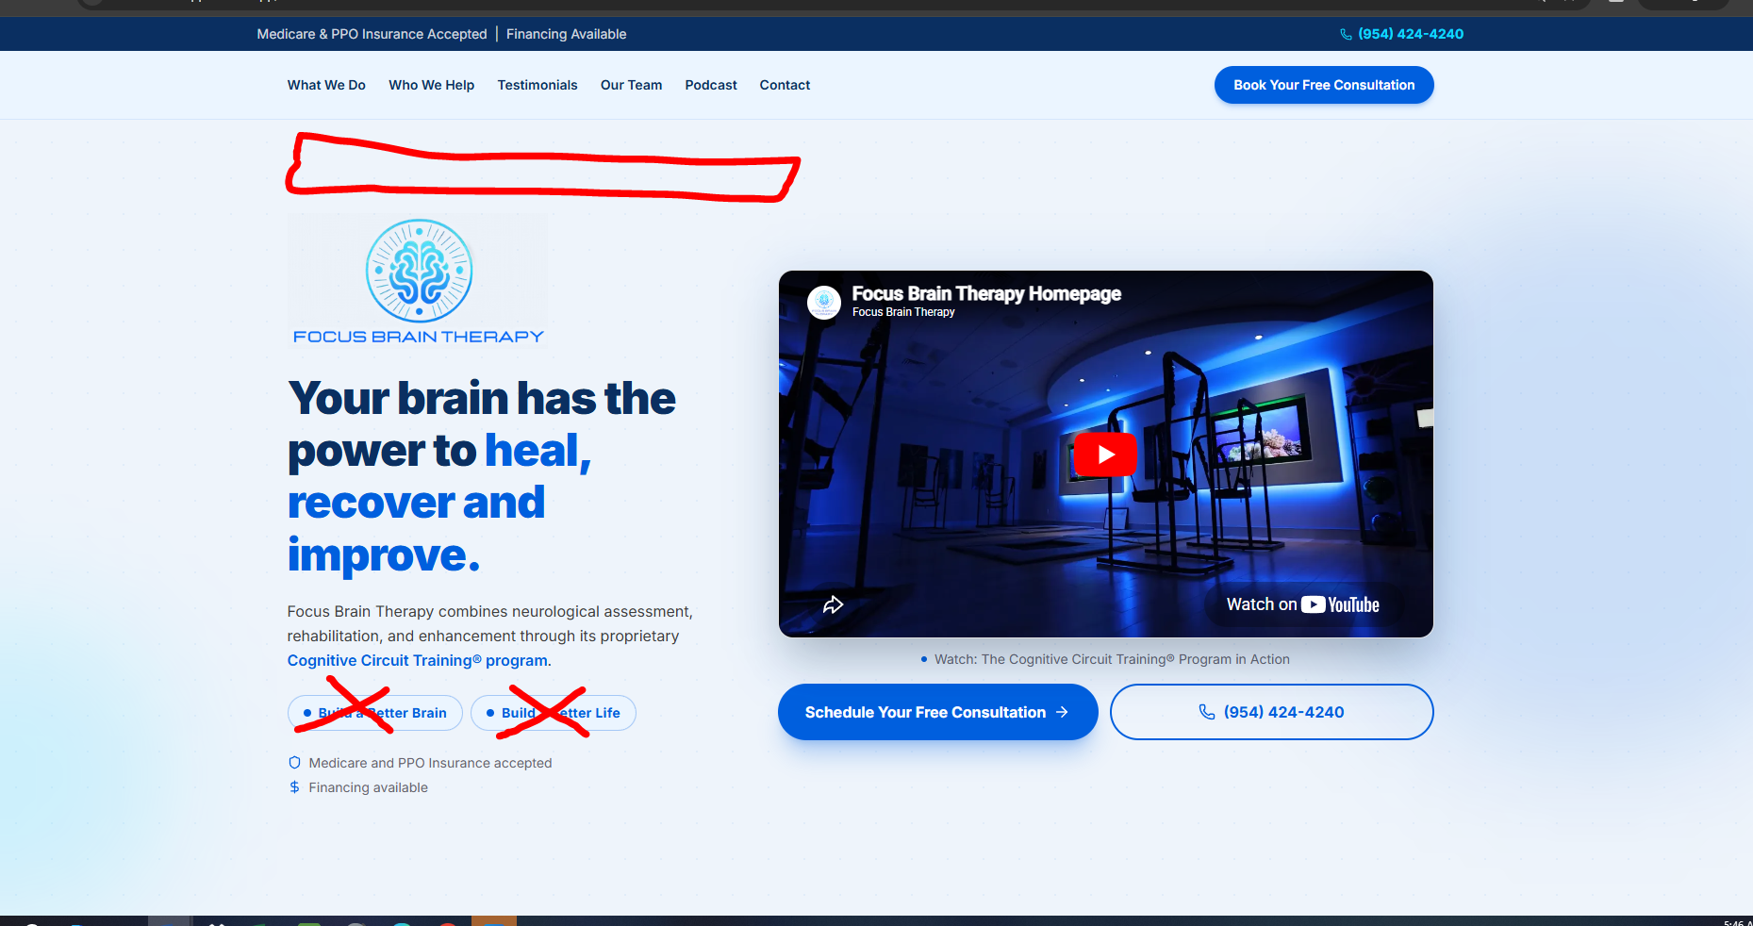

COGNITIVE CIRCUIT TRAINING
On the picture of the front desk, remove text: Our facility – Davie, Florida.

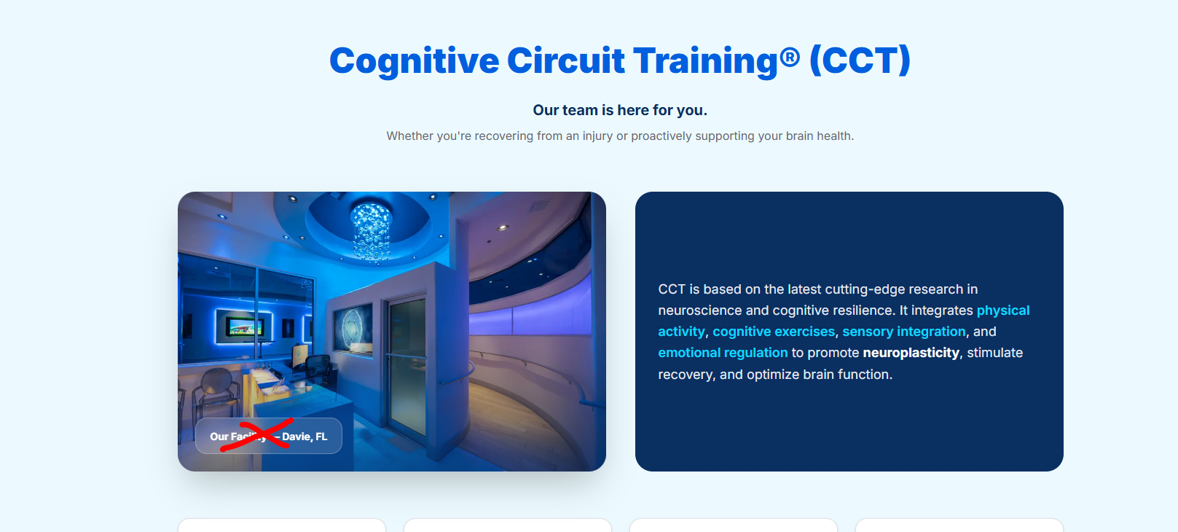

MEET OUR PASSIONATE TEAM
Replace this image with new one that is attached in the Task Files name as the client said she t tweaked it a little.

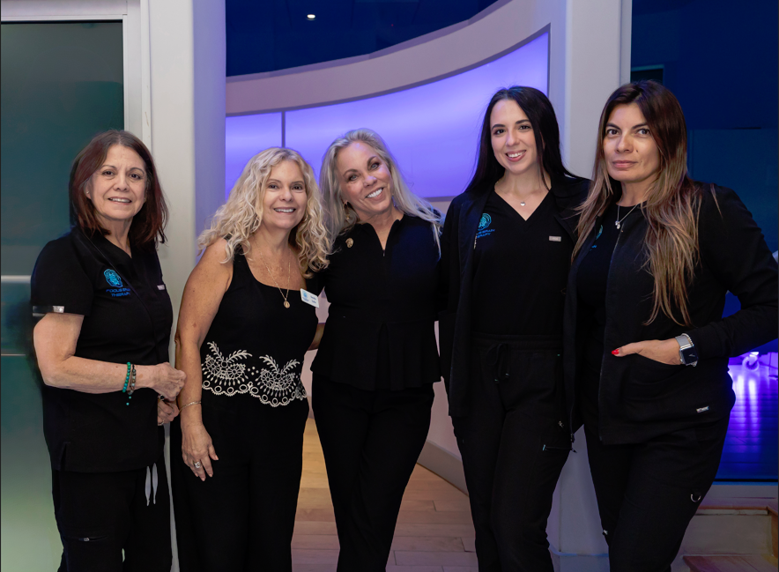
WHERE RECOVERY HAPPENS
Replace these two pictures.

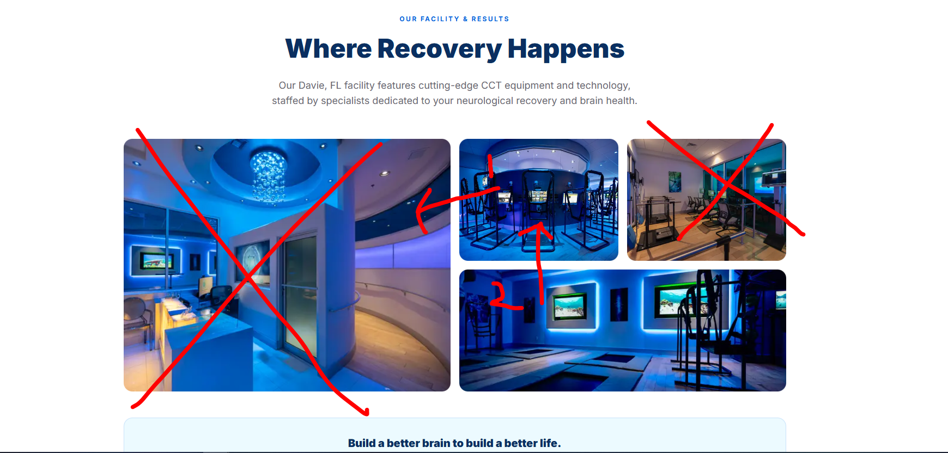

New Images
1. Make this image the big one
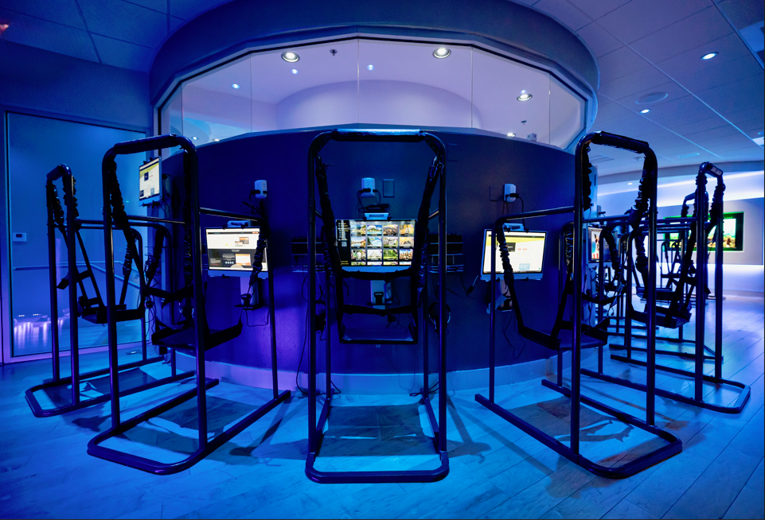
2. Move the one at the bottom up to the 2nd position
3. New image where the brown picture was in right hand corner
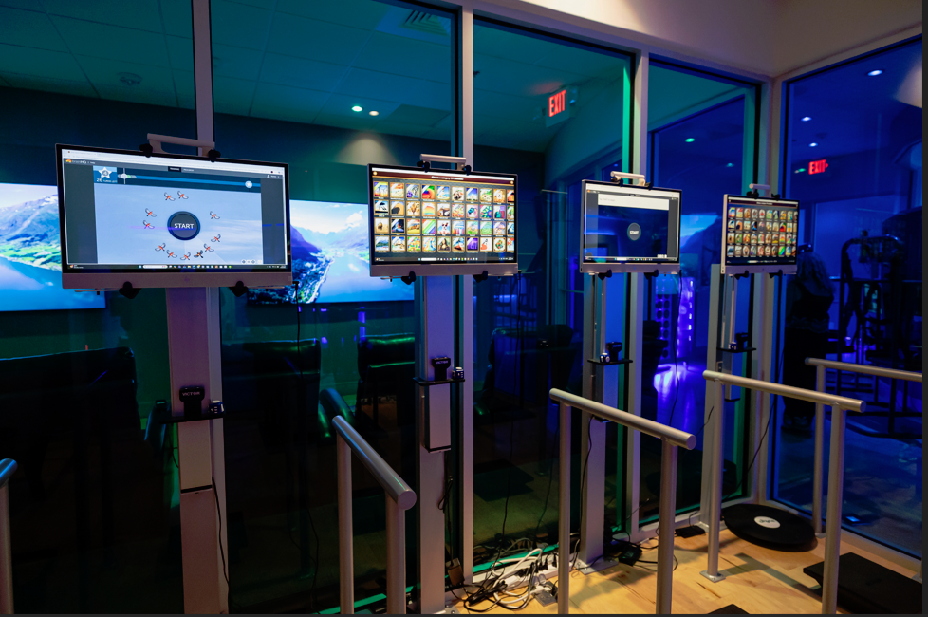
4. Add this one at bottom right
